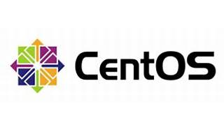



Explore

[**CentOS** is an open-source project that releases two distinct Linux distributions: **CentOS Stream** (the upstream development platform for upcoming Red Hat Enterprise Linux product releases) and **CentOS Linux** (derived from source code released by Red Hat)](https://www.redhat.com/en/topics/linux/what-is-centos) [1](https://www.redhat.com/en/topics/linux/what-is-centos).

Here are **five free learning resources** to help you explore CentOS:

1. [**CentOS Online Courses on Class Central**](https://www.classcentral.com/subject/centos): This collection includes courses from platforms like Coursera, YouTube, Udemy, and LinkedIn Learning. You can learn CentOS, earn certificates, and decide which class suits you best.
2. [**Learn CentOS on YouTube**](https://www.classcentral.com/course/youtube-learn-centos-80359): A comprehensive YouTube course covering topics such as installation, navigating the GNOME desktop, managing users, scripting, and more. Perfect for beginners!
3. [**Getting Started with CentOS**](https://www.freecodecamp.org/news/getting-started-with-centos-15eac7215c99/): A step-by-step guide to installing CentOS 7, exploring the Linux filesystem, and understanding basic commands.
4. [**What Is CentOS? - Red Hat**](https://www.redhat.com/en/topics/linux/what-is-centos): Red Hat’s official page explaining CentOS, its differences from CentOS Stream, and its role in the Linux ecosystem.
5. [**About CentOS - The CentOS Project**](https://www.centos.org/about/): Learn about the CentOS Project, its community-driven efforts, and how it provides a rich base platform for open source communities.

Happy learning! 🚀🐧